

Programme | : | M.Tech Int Software Engineering | Semester | : | Fall 2026-2027
Course | : | Database Systems Lab | Code | : | IASWE206
Faculty | : | Dr. M. Premalatha | Slot | : | L31+L32

Ex. No. 7
Date: 31-08-2026
SQL Joins

Note:
LMS Submission Format [Word File]
Regno, name
Course code, course title
Slot
Faculty Name
Question
SQL Query – Text Format (Copy Paste)
Screenshot

Ex:
Question:
create a student table with attributes regno, name, mobno and dob with appropriate datatypes and sizes

Query:
SQL> create table student_mp(regno varchar(4), sname char(10), mobno number(10), dob date);
Table created.

Screenshot:

SQL> desc student_mp
Name Null? Type
----------------------------------------- -------- ------------
REGNO VARCHAR2(4)
SNAME CHAR(10)
MOBNO NUMBER(10)
DOB DATE
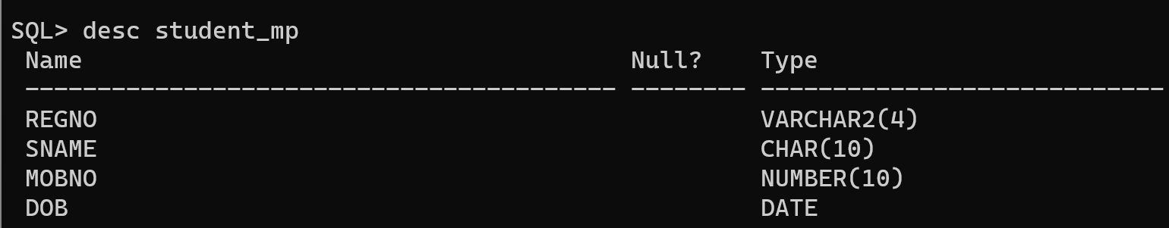
student(regno, sname, cgpa, school)
course(ccode, cname, credits)
faculty(empid, fname, designation, salary)
course_student(regno, ccode)
course_faculty(fid, ccode)

From the already created tables with key constraints of the above specified schema, write the SQL queries for the following by applying a minimum of 2 different join functions for a query.

- List the students details who have taken BCSE302L
- List the faculty names with designation “Professor” who teaches “BCSE302L”
- List the name of the faculty members who teaches “Database Systems”
- List the name of the students who have registered more than 2 courses.
- List the course name, registered by the register number “22BCE1001”
- List the courses with more than 2 credits which was taught by the faculty “Anand”
- List the students with >9 CGPA and has taken BCSE303L course taught by “Prof. Sai”
- List the register number, name, course code, course name and faculty empid, name involved in the course BCSE102L
- List the courses registered by sai.
- List the courses details registered by atleast one student and handled by a faculty
- List the students who has registered for more credits greater than all students using subqueries
- If a student has less than 7 cgpa, increase his cgpa by 1

